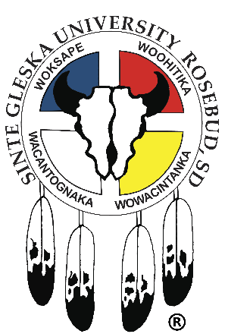
SINTE GLESKA UNIVERSITY
JOB ANNOUNCEMENT
_____________________________________________________________________________________
Position: Range or Natural Resource Mgmt. /Agriculture-(Faculty) Department: Arts & Science
Supervisor: A&S Dept. Chair Contract: 12 month/Salary
JOB SUMMARY:
Prepare and teach lecture/lab courses in range and natural resources management, botany, soil science, agricultural science, as well as others in area of interest. Faculty will be expected to teach introductory courses in chemistry, biology. Or physics depending on their qualifications. Fulltime faculty members have a responsibility to actively participate in an institution of higher learning to benefit and engage with students and colleagues in realizing the mission of Sinte Gleska University. This participation manifests scholarship, service and teaching.
Qualifications: Faculty must possess credentials one degree beyond the courses they teach- or possess appropriate and relevant experience and/or expertise. At a minimum, Master’s degree in Range Management, Natural Resources Management, Agricultural Science, or related field. PhD preferred.
Expertise or interest in Bison management and/or industrial hemp production is highly desirable.
Additional Information: Sinte Gleska University does not discriminate on the basis of race, color, national origin, sex, religious preference, age, handicap, marital status, political preference, or membership or non-membership in an employee organization, except as allowed by the Indian preference provision of the Civil Rights Act of 1964, as amended.
Any member of the academic department is responsible for ensuring that his/her personnel file is current with regard to official evidence of experience and educational qualifications. Failure to do so prior to the start of the contract year may result in not receiving compensation commensurate with claimed advancement in promotional steps.
To apply submit a completed SGU job application with a copy of your HS diploma or GED certificate, Driver’s license, Transcripts, verification of college degree and or certificates, Tribal ID or abstract and proof of COVID-19 vaccination to the HR Department. Applications are available on the SGU website. Open until filled. For further information and position description, contact Brenda I. Farmer, HR Director in care of the SGU HR office @the Antelope Lake campus-Administration Bldg. or call 605.856.8261/Brenda.Farmer@sintegleska.edu. Incomplete applications will not be considered.

