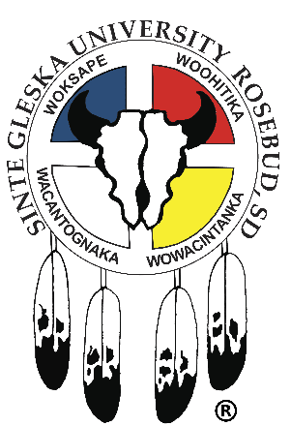
SINTE GLESKA UNIVERSITY
JOB ANNOUNCEMENT
_____________________________________________________________________________________
Position: Faculty (Instructor) Department: Lakota Studies
Supervisor: Department Chairperson/Director Contract: Full-Time/Faculty
Note: Faculty (Instructor) will be under the direct supervision of the Director/Chairperson of the Lakota Studies Department.
Qualifications:
- Master’s degree preferred with demonstrated knowledge in Lakota Studies; or other Master degrees with/including known expertise in Lakota Studies will be considered.
- Bachelor’s degree in Lakota or American Indian Studies required with demonstrated knowledge in Lakota Studies; other Bachelor degrees with known expertise in Lakota Studies will be considered.
- Established teaching experience in higher education; or other teaching experience will be considered.
- Established ability to teach Lakota language, culture, history, etc. (any Lakota Studies courses) from the Lakota Studies curriculum.
- Knowledge of tribal law, history, culture, philosophy, and language.
- Ability to conduct research, or assessment or evaluation in Lakota Studies.
- Technology skills required.
- Lakota speaking and/or understanding, beneficial.
- Must take and pass pre-employment alcohol/drug test and background check.
- Must have the ability to establish and maintain effective working relationships with staff, faculty and the general public.
- Must possess excellent organizational skills and performs duties in a timely manner with minimum supervision.
- A strong work ethic.
- A valid South Dakota driver’s license.
- Must have reliable transportation.
Sinte Gleska University does not discriminate on the basis of race, color, natural origin, sex, religious preference, Age, handicap, marital status, political preference, or membership or non-membership in an employee organization, except as allowed by the Indian preference provision of the Civil Rights Act of 1964, as amended.

To apply submit a completed SGU job application with a copy of your HS diploma or GED certificate, Driver’s license, Transcripts, verification of college degree(s) and or certificates, Tribal ID or abstract and proof of COVID-19 vaccination to the HR Department. Applications are available on the SGU website. Open until filled. For further information and position description, contact Brenda I. Farmer, HR Director in care of the SGU HR office @the Antelope Lake campus-Administration Bldg. or call 605.856.8261/Brenda.Farmer@sintegleska.edu. Incomplete applications will not be considered.

